**4.2: Triangle Relationship Task HW**

*20 points*

1. For the Creativity-Activity-Service (CAS) requirement of the IB program, you volunteer to help build a new sandbox at a local elementary school playground. You have two boards that will make up two sides of the triangular sandbox. One is 5 feet long and the other is 8 feet long. You can pick between boards of 15 feet, 12 feet, 8 feet, 5 feet, and 2 feet for the third side of the sandbox. Which boards can you use to make the triangular sandbox? Explain in the space provided.

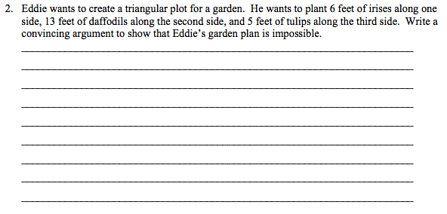

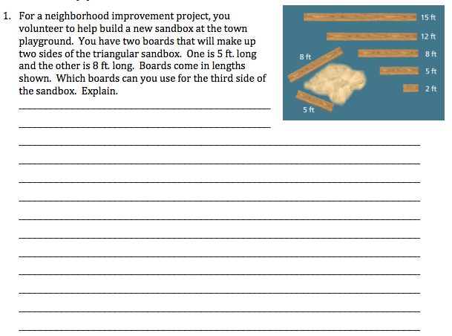

*You will receive:*

*3 points for identifying the correct board(s): _______/3*

*2 points for an explanation using correct terminology _______/2*

1. Eddie wants to create a triangular plot for a garden. He wants to plant 6 feet of irises along one side, 13 feet of daffodils along the second side, and 5 feet of tulips along the third side. Draw a picture in the space provided and write a convincing argument to show that Eddie’s garden plan is impossible.



*You will receive:*

*2 points for using a numerical argument: _______/2*

*2 points for using correct terminology _______/2*

1. Two sides of a triangle have lengths 3 and 7. Find the range of possible lengths of the third side. (*2 points)*
2. If 7, 12, and s are the lengths of three sides of a triangle, and s is not the longest side, what are the possible values of s? *(2 points)*
3. 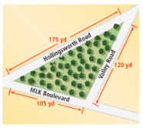Dorian, a landscape architect, is designing new triangular park in Brooklyn. (*2 points)*  
   1. He wants to place a bench at the corner with the largest angle. Which two streets form the corner with the largest angle?
   2. Suppose he wants to place a drinking fountain at the corner with the smallest angle. Which two streets from the second largest angle?
4. A family drives across Kansas on Interstate 70. A sign reads, “Wichita 90 mi, Topeka 110 mi.” Your little brother says, “I didn’t know that it was only 20 miles from Wichita to Topeka.” Explain why the distance between the two cities does not have to be 20 mi.

____________________________________________________________________________________________________________________ ____________________________________________________________________________________________________________________ ____________________________________________________________________________________________________________________ ____________________________________________________________________________________________________________________ ____________________________________________________________________________________________________________________

*You will receive:*

*3 points for using a numerical argument: _______/3*

*2 points for using correct terminology _______/2*